**DESCRIBING THINGS**

Here different objects can be described differently like simple descriptions of things or giving an autobiographical touch to things. For example, describing My Watch, A Coin, My Story Book, The Blackboard etc.

**Example 1 ‘My Watch’ Silver watch, in jeweler’s shop**

* Other watches there - the simple ones.
* Your father asked for the silver watch lying on the counter.
* Your liking - given to you as a birthday present.
* Importance of the watch.
* Your love for the watch.

**Example 2 ’The Autobiography of a Rupee’**

* Rupee coin - how it was formed - its history
* Used in earlier days and even now for what.
* How it is useful to man.
* What if there is no rupee and so on.

Proceeding this way, a beautiful creative speech can be framed out.

When you wish to describe anything, you must have an eye for detail. You must be a good observer. Suppose you were going for a walk. There was a middle aged man struggling up the road on his bicycle. Suddenly, a car came at a great speed, its horn screaming, and its fence struck the cyclist. The bike and the man fell down. The car did not stop. There was an inquiry. The police inspector asked you:

The Inspector : Can you identify the car?

You : It was a big car. I think it was a Tata Sumo.

The Inspector : Are you sure? What was its colour?

You : Yes. It was a Sumo. And it was olive green.

The Inspector : Can you remember the number of the car?

You : No, I am sorry. It happened so quickly. I was looking at the cyclist who fell down.

The Inspector : Couldn’t you at least see if the car was from this state or from outside?

You : Well, the first letters were definitely MH 12 or something. Quite certainly MH.

The Inspector : Well, thank you.

You can see how details are very important. The inspector can now concentrate on a Sumo car or cars registered in Maharashtra. The search can, thus, be restricted to those cars only.

Note the pattern of descriptive sentences:

It was -------------

The car was --------

The first letters were -------

Some people have a habit of noticing details and they remember them. There are a number of things in our house, in the hall, in the kitchen, in the bedroom, etc. But, if you are asked to describe the things in the kitchen or the hall or your own room, will you be able to describe them? Here is the picture of a kitchen. There are a number of things and gadgets in the kitchen

**For Example: [The Picture of a Kitchen]**

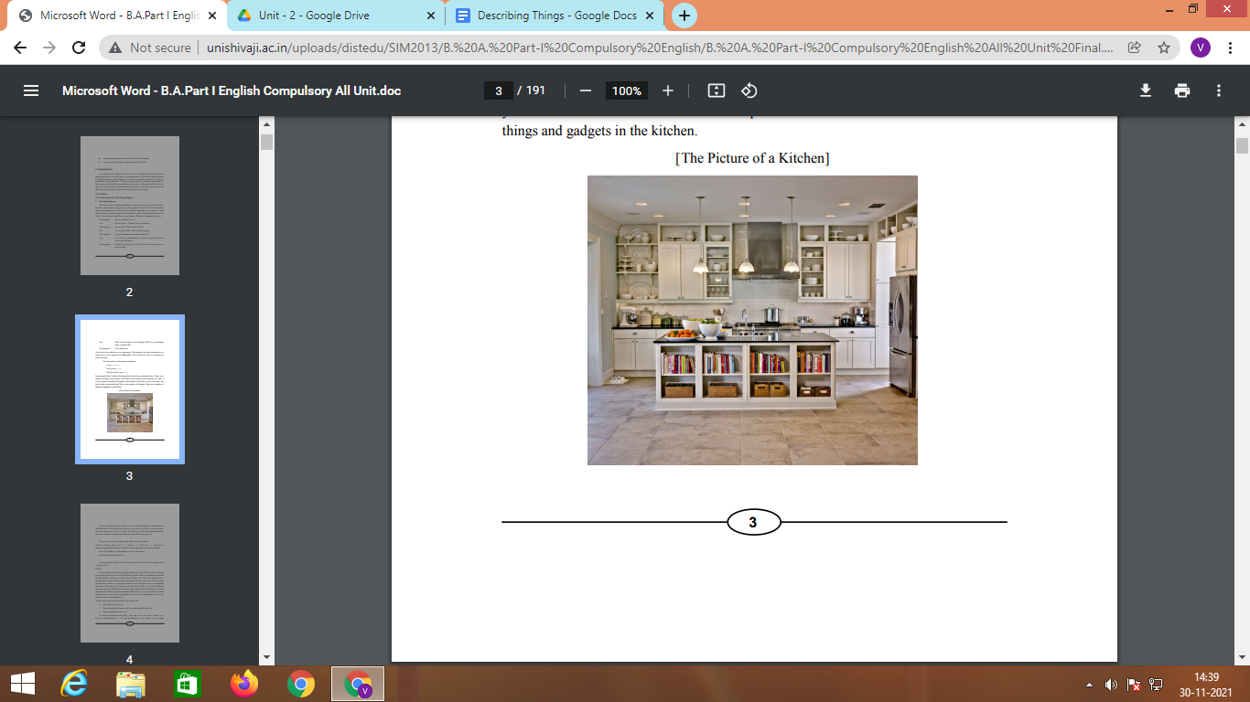

This is a kitchen platform. Above it, there is a small cupboard in which there are kettle and pans. On the platform, there is a gas-stove as well as a microwave unit. Near the microwave, there is a gas-stove as well as a microwave unit. Near the microwave, there is a sink with water-taps. Below the kitchen platform, there are a number of cupboards to keep big and small dishes, pots, etc.

There is also a waste-bin at the right hand side of the platform.

Note the structure again: This is ----, There is -----, There are -----. Note also a number of prepositional phrases used here to state the place or location of things:

above the platform, on the platform, near the microwave,

below the kitchen platform, etc.

**Topic for Example**

**OVEN:**

Oven is a device for baking, grilling, heating, etc. It is an electric device. It has a see-through glass door to view the food being cooked. There are stainless steel black heating elements at the top and the bottom of the oven. They are controlled by a thermostat to provide uniform temperature inside the oven. We can see these through the glass door. There is a wire grill inside the oven. The glass door is a drop-down front door, which gives you easy access to the interior of the oven. On the top right hand side, there is a black knob for temperature control. Below that there is a heater selection knob. There are heater indicator lights also. It is a very useful device in the kitchen. We can use it for toasting bread. It can grill the sandwiches for us. It can also be used to fry groundnuts, etc.

Note how the oven is described here. We start with:

1. what kind of a device it is.

2. Then we described its parts such as the see-through glass door, etc.

3. then we noted how useful it is.

We made use of the structures like : The oven is / has, It is / has, There is / are. They are controlled (by) ----, etc. In the description of an object, we use simple present tense. If we are talking about the things in the past, we can use simple past tense. But in any case we describe the appearance, the parts, function and usefulness of the thing we are describing.

**Note:**

Know the difference between EVENT and INCIDENT through the link below

<https://www.databarracks.com/blog/whats-the-difference-between-an-event-and-an-incident>

**Describing Events**

We witness events. Pleasant or unpleasant ones. For example, A House on Fire, My Birthday, Our Annual Day in School, A Bus Accident and so on. There are many more events that can be described.

**Example 1 ‘A Motor Car Accident’**

These days a craze for speed is mainly responsible for many accidents and innocent people lose their lives for nothing. I witnessed one such accident while I was with my parents on the Srinagar – Baramulla road. We were having some ice cream when two guys were coming fast on a motorbike. The rider had put on an earphone into his ears and was riding so fast that he passed with a splashing sound. Within a fraction of a second, there was a big bang and we looked back. The boys had bumped into a motor car. The boys got severe injuries. The passengers in the car, the driver, his wife and their small kid all were badly injured. I don’t know what happened to the guys afterward but I know one thing “Speed thrills but kills’.

**Describing an Incident:**

Go through the link below to find a list of **adjectives** to describe a thing/an event/an incident

* <https://describingwords.io/for/incident>

Go through the link below to find a list of **Idioms** to describe a thing/an event/an incident

* <https://www.learn-english-today.com/idioms/idiom-categories/descp-pl-things/description-thgs1.html>
* <https://preply.com/en/blog/9-idioms-in-english-to-describe-cities-places-and-events/#scroll-to-heading-0>

**Example Question for describing Incident:**

# Narrate an incident from your own experience when you expected to do very well, but for some reason were unable to do so. Explain what happened and why it happened. What lesson did you learn from it?

**Answer**:

## Each one of us has some or the other qualities in ourselves which differentiate us from other people. The vital need is to search it out of our soul and when we have sought it, excelled in it, and the need of the hour then is to be humble and not be overconfident. When we excel in a particular field, all have high expectations from us to perform well. There the humbleness and sincerity of our mind comes into play.

## I too possess a talent and this is how I became aware of it. One day, I went to play badminton and I was astonished to find that the traditional and basic shots came naturally to me. I thought that this was an extraordinary trait gifted to me. I started to pursue my career as a badminton player. I worked hard for two years until I became the champion at the district level. I had stepped into the professional panel of this game. I thought that I was the best in the district and this thought convinced me to decrease the length of my practice sessions and my mind was on the seventh heaven. I stopped paying attention to senior players or the coach's advice.

## Days passed, it was time now for the state level tournament. After winning districts, I had lost my humble attitude and was full of over-confidence. I thought that I would conquer the state level forgetting that there were many other district level players like me. To my utter surprise, I was knocked out in the first round by a player whom I had defeated at the district level. It was an extremely shocking and traumatic moment for me.

## I had let down my parents and my coach and I felt ashamed to show my face to them. My coach came searching for me and I feared that he would lash out at me for losing such an important match, but rather he was calm and affectionate. In a matter of five minutes, he taught me the greatest lesson of my life- hard work and humbleness.

## He explained he had been noticing my change of attitude which was the cause of my downfall. He also pointed to my over-confident behaviour and advised that one should always be rooted to the earth, no matter whatever height of success one reaches. Moreover one should always be humble and respectful at all times even to our opponents. From then on, I vowed to follow my guide's advice all my life.

## My coach wanted to teach this lesson in a practical way, therefore didn't point out my shortcomings earlier. Though I suffered a big defeat, it is never too late to pick up the shreds and weave a bed of roses for yourself.

**Note:**

You can choose any topic from the list below or you can choose any relevant topic.

**List of topics for describing things**:

* My favorite place in my hometown.
* My perfect vacation.
* My perfect space.
* My dream apartment.
* Describe an object that is special to you.
* Give a tour of one room in your house by describing the most important objects in that room.
* Describe one of your favorite outfits.
* Describe your favorite toy as a child.
* Describe how you get around (for example: a bicycle, skateboard, sneakers, your parents’ car, the school bus).
* Describe your favorite piece of furniture where you like to spend time and relax.
* Describe something that you would bury in a time capsule to tell people about what life is like today.
* Describe an object that has been in your family for a long time.
* Choose a piece of food to eat; then, write a description of it that includes the way it looks, smells and tastes.
* Describe a smartphone to a time traveler from the 1900s.

**List of topics for describing Events:**

* My first trip overseas. …
* Describe a memorable concert you attended.
* Describe a memorable trip you took.
* Describe a special time that you and your family had together.
* Describe the first time you met one of your friends.
* How did you celebrate the new year?
* My visit to a hill station
* My first visit to a big city
* A quarrel at an election booth
* How did I feel when I reached the exam hall late?

**List of topics for describing Incidents:**

* An incident I can not forget
* A day without electricity
* A period without a teacher
* An accident that I have seen
* Describe an incident that changed your life
* Describe an incident when you helped someone

**Videos for describing things, events and incidents**:

* <https://www.youtube.com/watch?v=BV3a2hJ3_E4>
* <https://www.youtube.com/watch?v=gtcMf-twhs0>
* <https://www.youtube.com/watch?v=fuDFz8AijfM>